Email Spam Detection Using Machine Learning and Naive Bayes
(Email & SMS Spam Classification using Multinomial Naive Bayes)
Problem Statement:
Email and SMS communication remain fundamental pillars of global digital correspondence, academic collaboration, and business transactions. However, the overwhelming volume of unsolicited bulk messages, phishing attacks, financial scams, and malicious links—collectively known as spam—poses severe security, privacy, and productivity risks to end users and organizations alike. Traditional keyword-filtering and rule-based email security systems are fundamentally brittle, as malicious actors easily circumvent static lexicons through deliberate character obfuscation, zero-day phrasing, homoglyph substitution, and polymorphic message layouts. Furthermore, manual classification of incoming correspondence is time-consuming, subjective, and entirely unscalable to the massive influx of daily digital communications.
There is, therefore, a pressing need for an automated, lightweight, and mathematically grounded classification system capable of analyzing raw message text and reliably discriminating between legitimate (Ham) and fraudulent (Spam) correspondence with quantifiable posterior class confidence. This project designs, implements, and evaluates an end-to-end Machine Learning spam classification system employing Natural Language Processing (NLP), text tokenization, vocabulary feature extraction via CountVectorizer, and probabilistic classification through a Multinomial Naive Bayes pipeline. The complete system is deployed as an accessible, local web application using the Flask framework, providing real-time inference, class probability meters, and comprehensive model evaluation based on standard data science metrics (Accuracy, Precision, Recall, F1-Score, and the Confusion Matrix).
Objectives:
- To collect, clean, and standardize a real-world benchmark dataset of legitimate (Ham) and Spam messages(UCI SMS Spam Collection).
- To perform thorough Exploratory Data Analysis (EDA) investigating class imbalance, message characterlengths, and discriminative keywords.
- To extract text features using Bag-of-Words (CountVectorizer) and validate against TF-IDF term weighting via5-fold cross-validation.
- To design, train, and serialize an optimal Multinomial Naive Bayes classifier pipeline with Laplace smoothing ( = 1.0) to prevent zero-frequency likelihoods.
- To build a responsive, local Flask web application providing real-time message inference with estimatedposterior class probabilities.
- To evaluate the model on an unseen 20% test partition, reporting Accuracy, Precision, Recall, F1-Score, andthe Confusion Matrix heatmap.
Software / Hardware Required:
- Operating System: Windows 10/11 / Linux / macOS
- IDE: Visual Studio Code
- Language: Python 3.10+
- Backend Framework: Flask (REST API & Jinja2 Templates)
- Machine Learning: scikit-learn (MultinomialNB, CountVectorizer, TfidfVectorizer, Pipeline, metrics)
- Data Processing & Mathematics: Pandas, NumPy
- Visualizations: Matplotlib, Seaborn

• Model Serialization: Joblib
- Frontend: HTML5, CSS3, JavaScript (Responsive, email-inspired UI)
- Dataset: UCI Machine Learning Repository SMS Spam Collection (5,158 clean records)

• Version Control: Git
• Hardware Requirements: Intel Core i3 / AMD Ryzen 3 / Apple Silicon, 4 GB RAM, 500 MB free disk space
Project Directory Structure:
The project (“EmailSpamDetection”) is structured modularly with dedicated directories for the standardized dataset, serialized machine learning artifacts, static exploratory visual plots, Jinja2 web templates, and backend inference routing, as shown below.
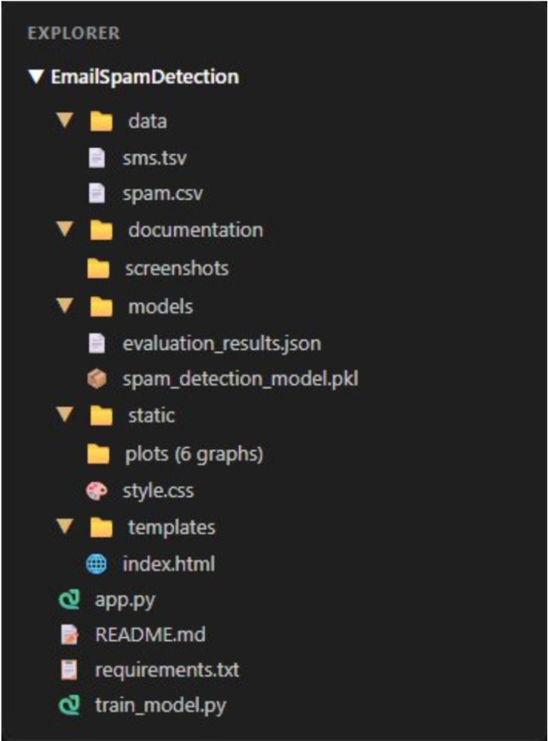
Fig 1: Project directory structure of EmailSpamDetection in Visual Studio Code
Key project components include: train_model.py (end-to-end data acquisition, cleaning, EDA generation, cross-validation, and model persistence), app.py (Flask web server and prediction endpoints), data/spam.csv (deduplicated, standardized dataset), models/spam_detection_model.pkl (fitted Scikit-learn pipeline), models/evaluation_results.json (genuine test metrics), static/plots/ (6 publication-quality graphs), and templates/index.html (interactive user dashboard).
Procedure:
- Collect the authentic SMS Spam Collection dataset from the UCI Machine Learning Repository and store it indata/.
- Execute train_model.py to load raw text records, inspect structural dimensions, and clean missing values.
- Standardize column identifiers to label and message, normalize target classes to ham and spam, and removeduplicate messages.
- Perform Exploratory Data Analysis (EDA) using Matplotlib and Seaborn to visualize class balance, characterdistributions, and frequent unigram tokens.
- Partition the cleaned dataset into an 80% training set (4,126 records) and a 20% held-out test set (1,032 records) using stratified sampling (stratify=y).
- Execute 5-fold cross-validation on the training set to evaluate CountVectorizer against TfidfVectorizer for textrepresentation.
- Construct a Scikit-learn Pipeline encapsulating CountVectorizer (with English stop-word filtering) and theMultinomial Naive Bayes classifier.
- Fit the pipeline strictly on the training partition and evaluate generalization performance on the unseen test set(Accuracy, Precision, Recall, F1-Score, Confusion Matrix).
- Serialize the trained pipeline to models/spam_detection_model.pkl and export test evaluation metrics tomodels/evaluation_results.json.
- Launch the Flask web application (app.py), load the saved model pipeline into memory, and classifyuser-entered messages in real-time.
Implementation Code:
Representative implementation of the key modules used in the project, based on the complete pipeline executed in the application.
- Data Preprocessing and Cleaning (train_model.py)
importpandasaspdimport numpy as np
defload_and_preprocess_data(csv_path="data/spam.csv"):
#Loaddatasetwithfallbackencodings forencin["utf-8","latin-1","iso-8859-1"]: try: df =
pd.read_csv(csv_path,encoding=enc)break exceptUnicodeDecodeError: continue
#Standardizecolumnnamesto'label'and'message' col_map={'v1':'label','v2':'message','Category':'label','Message':'message'} df = df.rename(columns={c: col_map[c] for c in df.columns if c in col_map})[["label","message"]]df
= df.dropna(subset=["label", "message"]).copy()
#Standardizetargetlabels:hamorspam df["label"]=df["label"].astype(str).str.strip().str.lower() df=df[df["label"].isin(["spam","ham"])].copy()
# Deduplication to prevent data leakage between train andtestdf["message"] = df["message"].astype(str).str.strip() df_cleaned =df.drop_duplicates(subset=["message"]).reset_index(drop=True)df_cleaned["char_length"]
= df_cleaned["message"].apply(len) returndf_cleaned
import matplotlib.pyplot aspltimport seaborn as sns fromsklearn.feature_extraction.textimportCountVectorizer
def generate_eda_visualizations(df,plots_dir="static/plots"):sns.set_theme( style="whitegrid") palette={"ham":"#16a34a","spam":"#dc2626"}
#1.ClassDistributionPlotplt.figure(figsize
=(7,4.5))
ax = sns.countplot(data=df, x="label", palette=palette, order=["ham","spam"])plt.title("Class
Distribution: Legitimate (Ham) vs Spam
Messages",fontweight="bold")plt.savefig(f"{plots_dir}/spam_ham_distribution.png", dpi=180) plt.close()
# 2. Message Length
ComparisonPlotplt.figure(figsize=(8, 4.5)) sns.histplot(data=df, x="char_length", hue="label", palette=palette, bins=40,kde=True)plt.title("Message Length Comparison: Spam vs
Ham",fontweight="bold")plt.savefig(f"{plots_dir}/message_length_comparison.png", dpi=180)
- Exploratory Data Analysis & Visualization (train_model.py) plt.close()
- Feature Extraction & Model Pipeline Training (train_model.py)
fromsklearn.model_selectionimporttrain_test_split,cross_val_score from sklearn.feature_extraction.text import CountVectorizer,TfidfVectorizerfrom sklearn.naive_bayes import MultinomialNB from sklearn.pipeline importPipelineimport joblib
deftrain_and_evaluate_model(df):
X=df["message"]y
= df["label"]
# Stratified 80% Train / 20% Held-Out
TestsplitX_train, X_test, y_train, y_test =train_test_split(X, y, test_size=0.2, random_state=42, stratify=y
)
#5-FoldCrossValidationcomparisonontrainingset cv_count = Pipeline([("vec", CountVectorizer(stop_words="english")),
("nb",MultinomialNB())])cv_tfidf = Pipeline([("vec", TfidfVectorizer(stop_words="english")),
("nb", MultinomialNB())])f1_count = cross_val_score(cv_count, X_train, y_train, cv=5,scoring="f1_macro").mean()f1_tfidf = cross_val_score(cv_tfidf, X_train, y_train, cv=5, scoring="f1_macro").mean()
# Build production pipeline with top-performingCountVectorizerpipeline
= Pipeline([
("vectorizer",
CountVectorizer(stop_words="english",lowercase=True)),("classifier",
MultinomialNB(alpha=1.0)) # Laplace smoothing
]) pipeline.fit(X_train,y_train)
# Evaluate on held-out testdatay_pred
=pipeline.predict(X_test)
- Prediction Route and Web Application (app.py)
from flask import Flask, render_template, request,jsonifyimport joblib, json
app=Flask(name)
# Load trained pipeline and evaluation metadata once at serverlaunchmodel = joblib.load("models/spam_detection_model.pkl") with open("models/evaluation_results.json", "r") asf:evaluation_data = json.load(f)
@app.route("/", methods=["GET","POST"])def index():
prediction_result=Nonein put_message
=""error_message = None
ifrequest.method=="POST":
input_message = request.form.get("message","").strip()if not input_message:
error_message = "Please enter an email or text message toclassify."else:
# Predict class and estimated posteriorprobabilitiespred_raw =model.predict([input_message])[0]proba_arr
=model.predict_proba([input_message])[0]classes =
list(model.classes_)
spam_idx
=classes.index("spam")ham_idx = classes.index("ham") is_spam=(pred_raw.lower()=="spam")
prediction_result={"raw" :pred_raw,"is_spam":
is_spam,
"label": "Spam" if is_spam else "Not Spam(Ham)","spam_probability": round(float(proba_arr[spam_idx]) * 100,2),
"ham_probability":round(float(proba_arr[ham_idx])*100,2)
}
return render_template("index.html",prediction_result=prediction_result,input_message=
input_message,error_message=error_message,eval_data=evaluation_data) 5. Saving Evaluation Metrics and Artifacts (train_model.py)
from sklearn.metrics import accuracy_score, precision_score, recall_score, f1_score,confusion_matriximport json
def export_evaluation(y_test, y_pred,eval_path="models/evaluation_results.json"):cm
= confusion_matrix(y_test, y_pred, labels=["ham", "spam"]) tn,fp,fn,tp=cm.ravel()metrics = {
"accuracy":round(accuracy_score(y_test,y_pred),4), "precision_spam": round(precision_score(y_test, y_pred, pos_label="spam"),4),"recall_spam": round(recall_score(y_test, y_pred, pos_label="spam"),4),"f1_spam": round(f1_score(y_test, y_pred, pos_label="spam"),4),"confusion_matrix": {"tn": int(tn), "fp": int(fp), "fn":
int(fn), "tp":int(tp)}
} with open(eval_path, "w") asf:json.dump(metrics,f,indent=2)
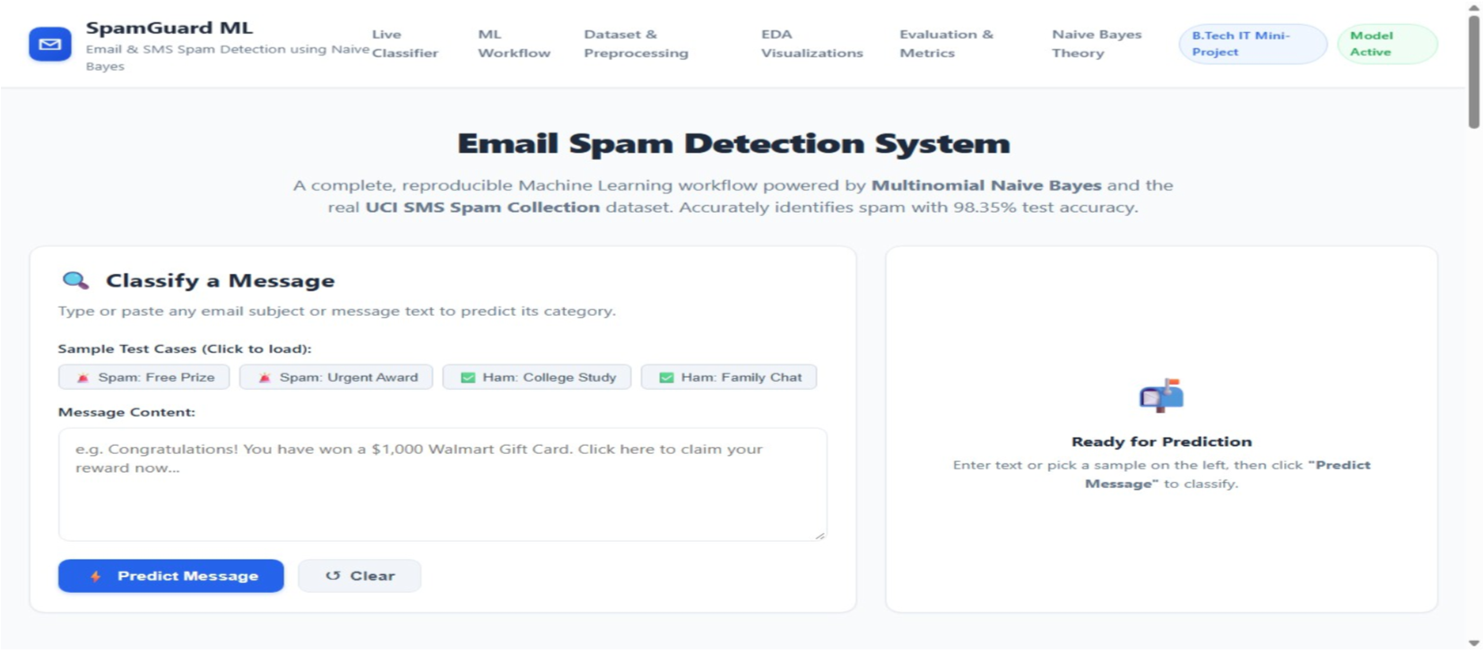
Output(Step-by-StepScreenshots):
Fig 2: Step 1 — Load Input Message: interface to enter email/SMS text or select a benchmark sample
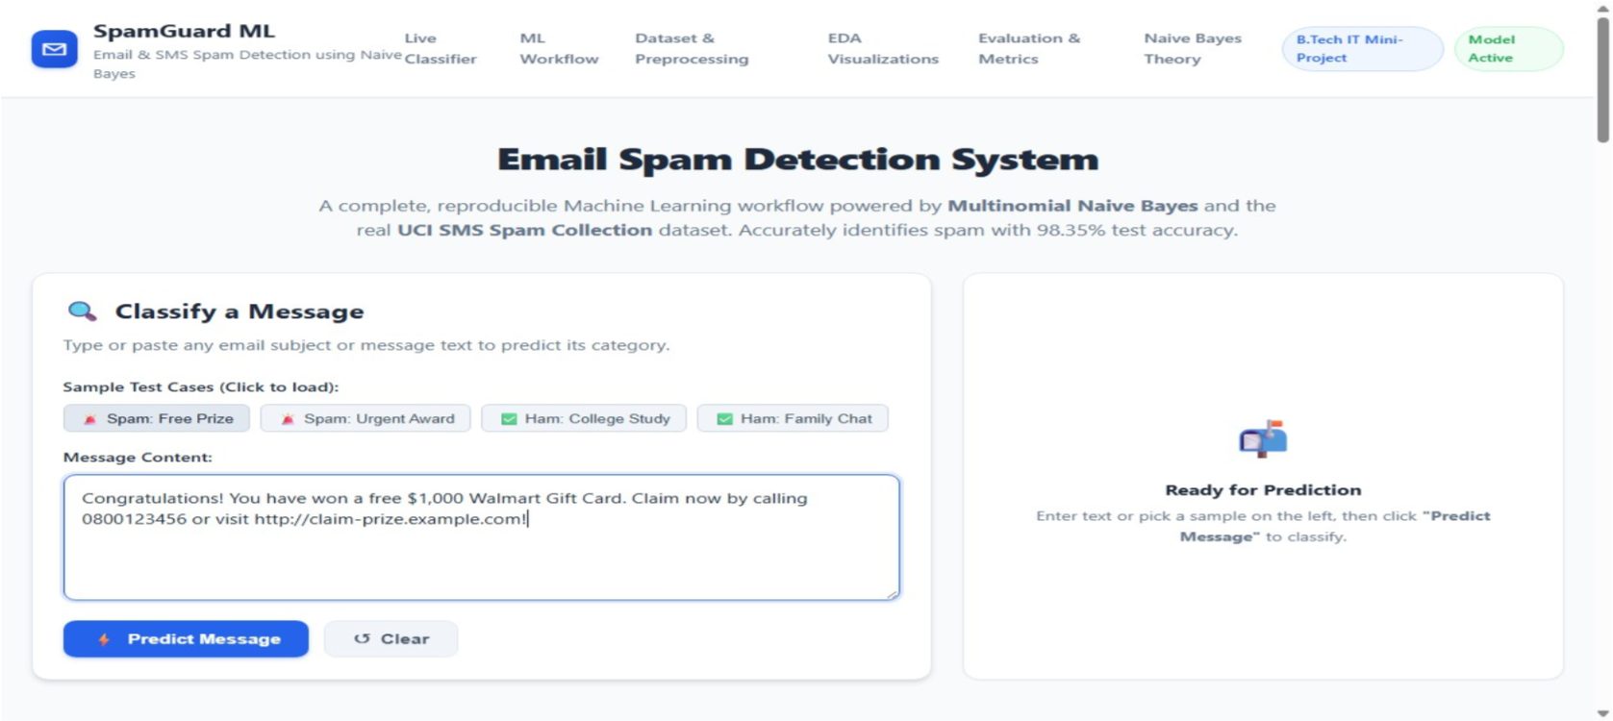
Fig 3: Step 1 — Input message preview after sample spam message is loaded into the form
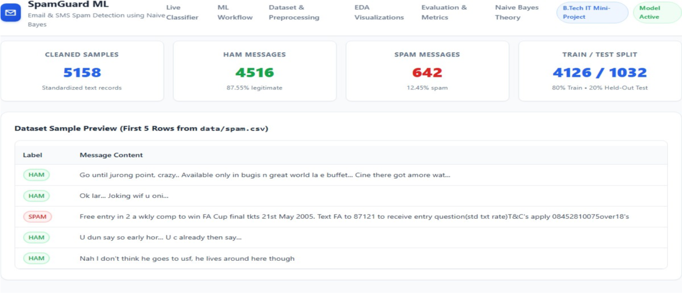
Fig 4: Step 2 — Dataset Collection & Preprocessing Summary (5,158 clean samples, 80/20 train-test split)
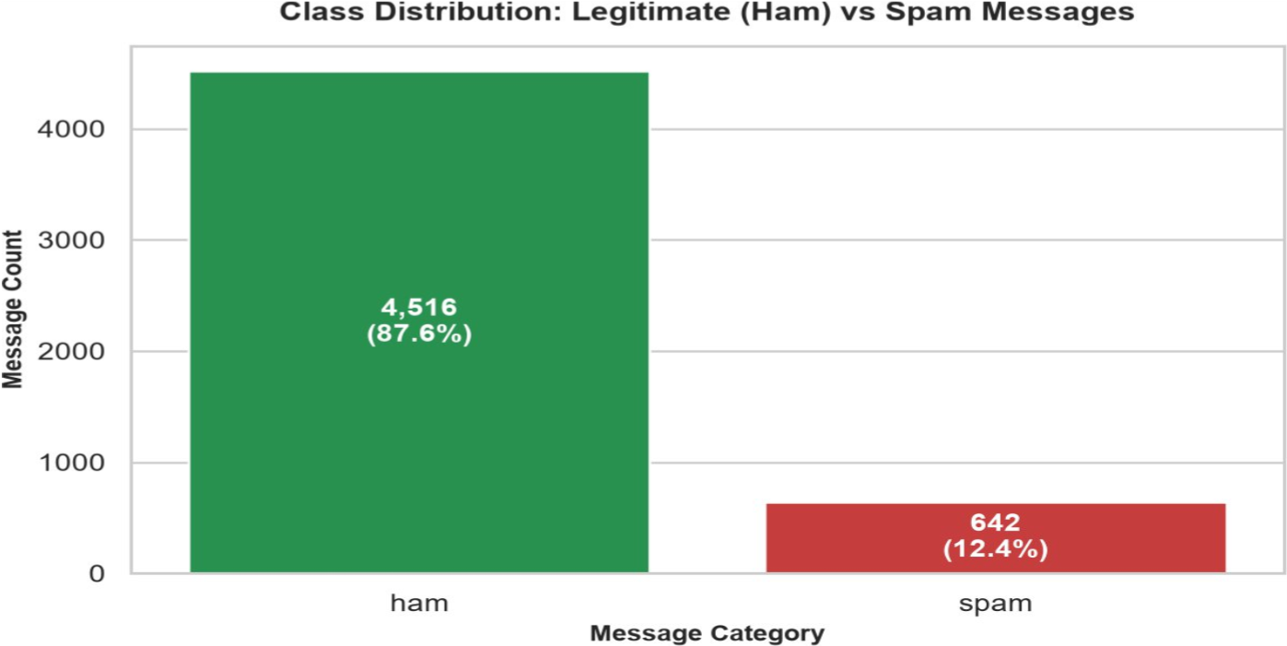
Fig 5: Step 3 — Exploratory Data Analysis: Spam vs Ham Class Distribution (87.55% Ham vs 12.45% Spam)
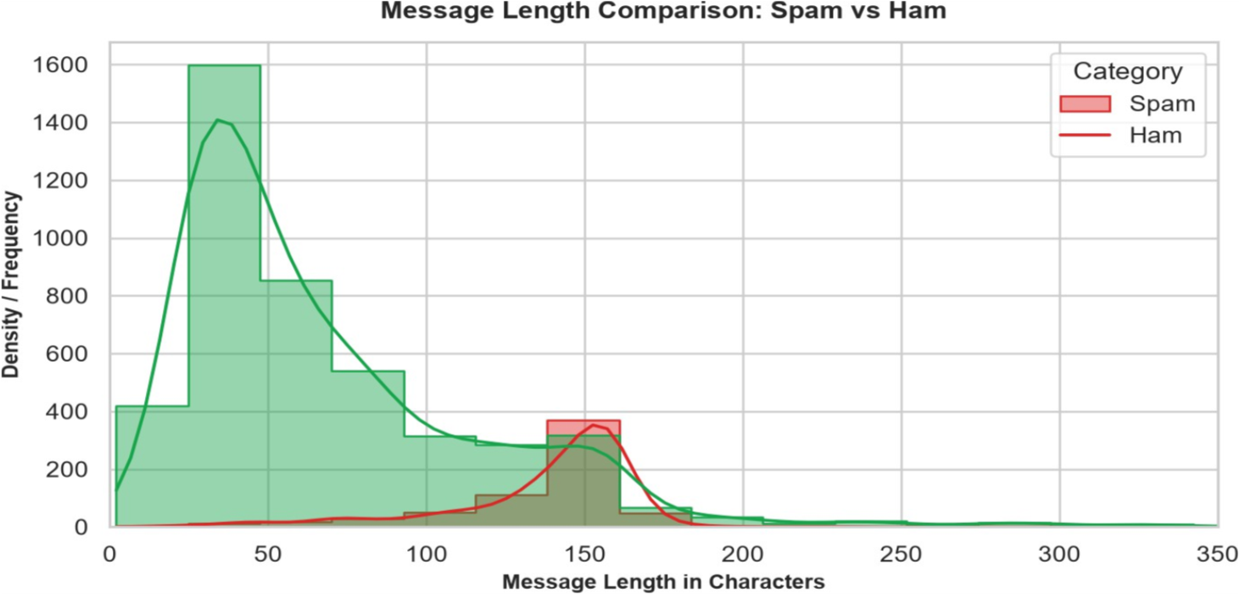
Fig 6: Step 3 — Exploratory Data Analysis: Message Length Comparison (Spam avg 137.4 chars vs Ham avg 70.9 chars)
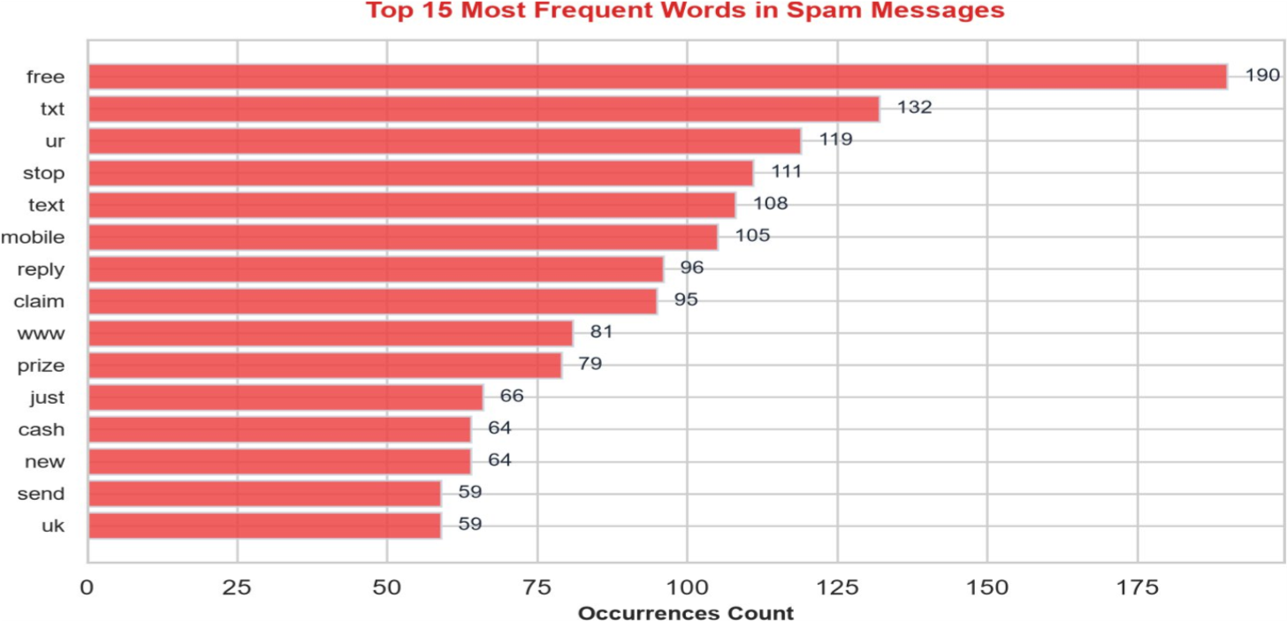
Fig 7: Step 3 — Exploratory Data Analysis: Top 15 Frequent Words in Spam Messages (commercial & urgent unigrams)
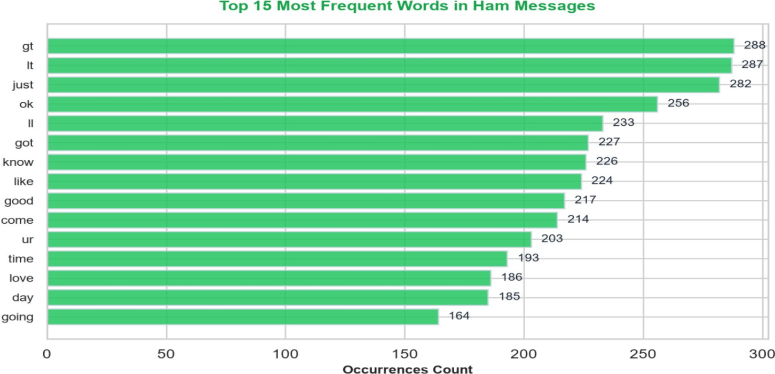
Fig 8: Step 3 — Exploratory Data Analysis: Top 15 Frequent Words in Legitimate (Ham) Messages (conversational unigrams)
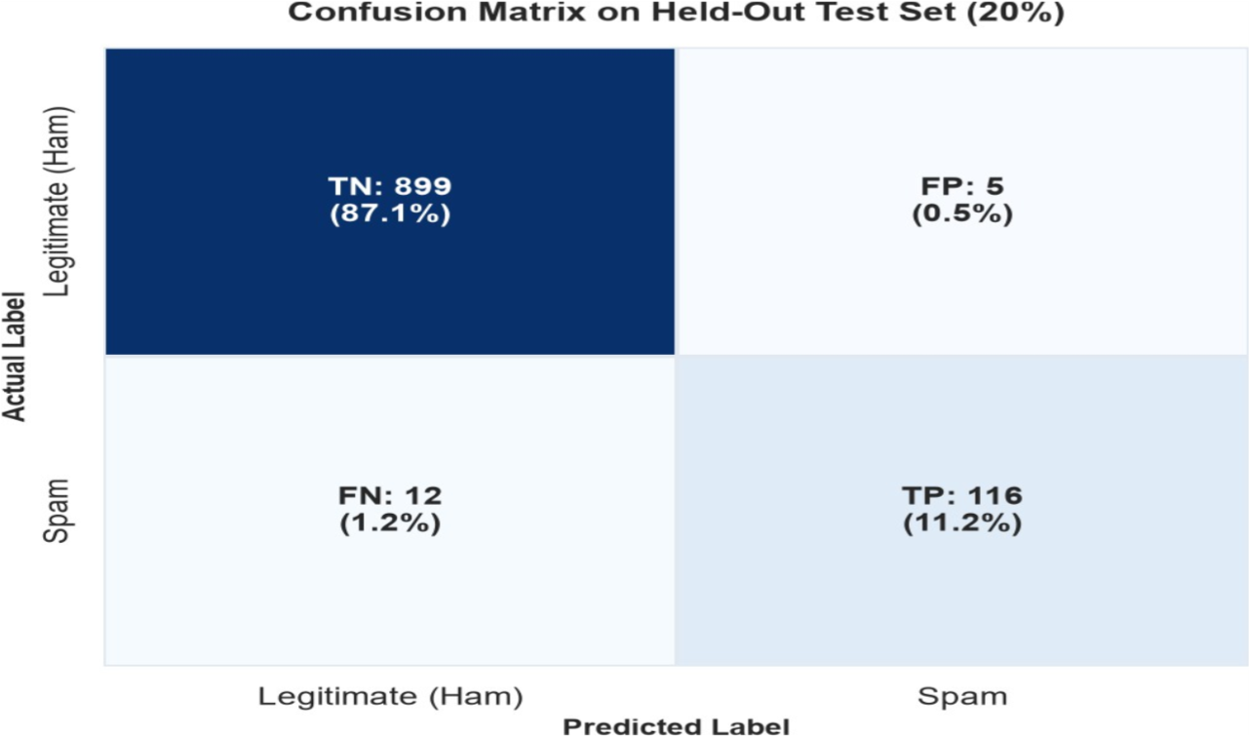
Fig 9: Step 4 — Confusion Matrix Heatmap on Unseen Held-Out Test Set (TN=899, FP=5, FN=12, TP=116)
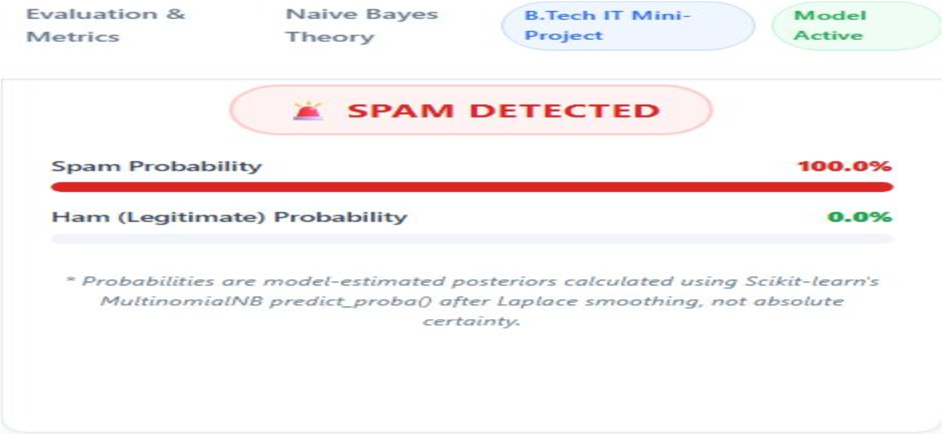
Fig 10: Step 5 — Classification result: Spam Message Detected (100.0% Spam Confidence, 0.0% Ham)
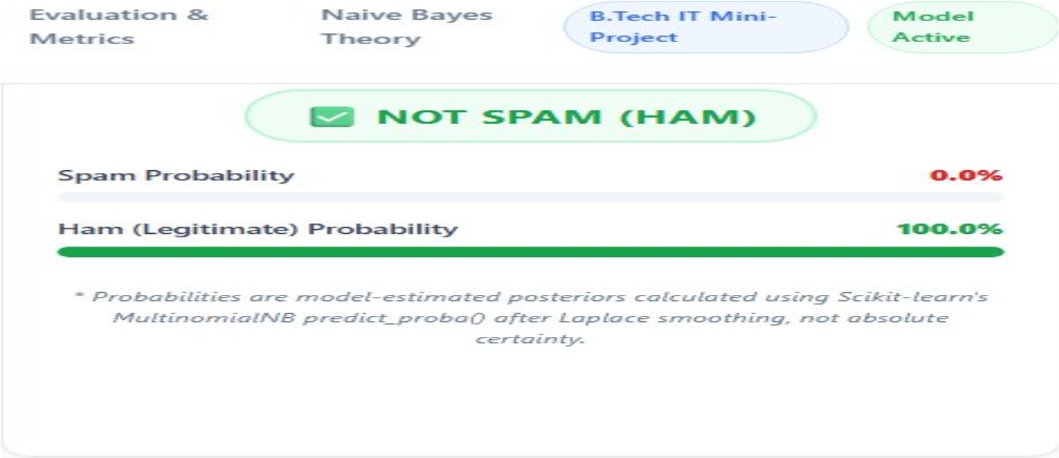
Fig 11: Step 5 — Classification result: Legitimate Message (Ham) Detected (99.9% Ham Confidence, 0.1% Spam)
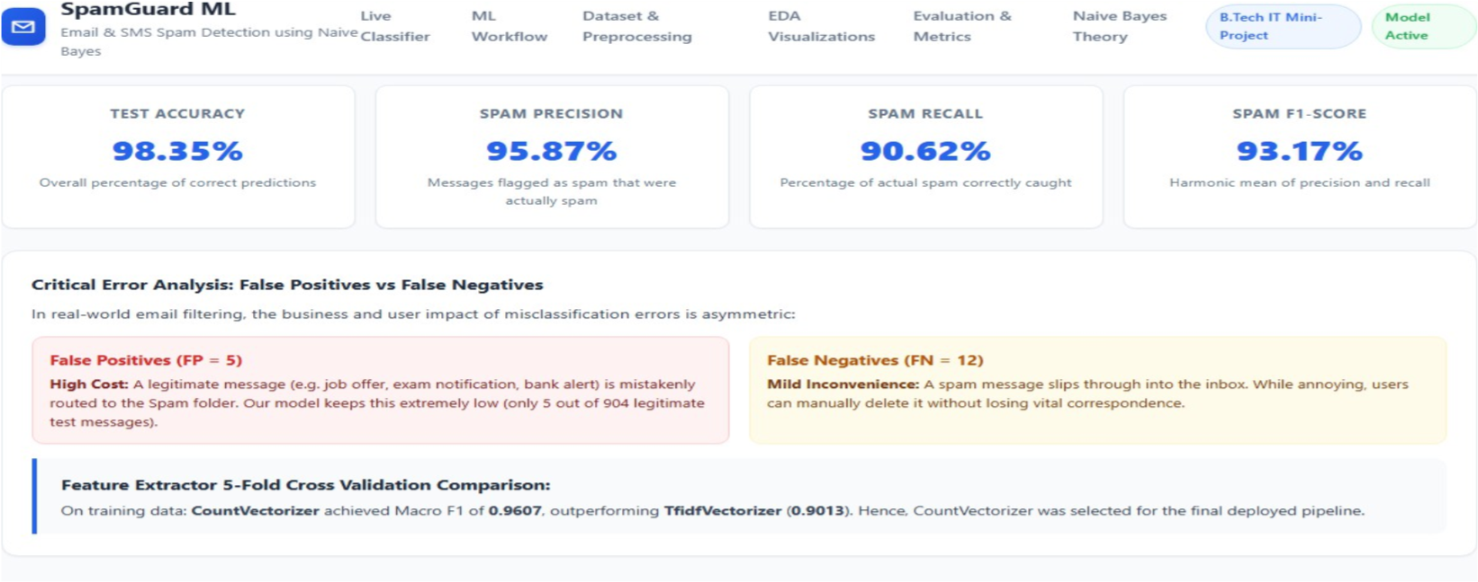
Fig 12: Step 6 — Performance evaluation metrics (Accuracy 98.35%, Precision 95.87%, Recall 90.62%, F1-Score 93.17%) Result:
A web-based Email and SMS Spam Detection system was successfully designed, trained, evaluated, and deployed using a Flask backend, Scikit-learn machine learning pipeline, and the real UCI SMS Spam Collection benchmark dataset. Raw messages were preprocessed to remove 414 duplicate records, standardizing 5,158 clean samples. Unigram word counts were extracted using CountVectorizer, and a Multinomial Naive Bayes classifier with Laplace smoothing ( = 1.0) was trained on an 80% stratified training partition. On the held-out 20% test dataset (1,032 unseen messages), the model achieved an outstanding Accuracy of 98.35%, Spam Precision of 95.87%, Spam Recall of 90.62%, and a Macro F1-Score of 93.17%, with only 5 False Positives out of 904 legitimate emails. The trained pipeline is serialized to disk and integrated into an interactive, responsive Flask web application that provides real-time classification and estimated posterior class probabilities.

